Title: | <Door Control module>  SW Architecture < XXXXXXX >

History
Issue status  (Index) | Maturity/Date  (draft/invalid/valid)  (dd-mmm-yyyy) | Author  Department | Check/Release  Department | Description
1.0 | Draft  28-ago-21 | Jose Garibay | Jose Garibay | Creation of the document

Table of Contents
1 Purpose 3
2 Definitions and abbreviations 3
3 Realization constraints and targets 3
4 SW Functional Architecture 3
4.1 Table of functions 3
4.2 Table of functional Interfaces 4
4.3 Functional Interface 4
4.4 Functional Interaction 4
5 SW Physical Architecture 5
5.1 Physical Decomposition 5
5.2 Table of SW components 5
5.3 Table of Physical Interfaces 5
5.4 Physical Interfaces 6
5.5 Physical Interaction 6
5.6 Describe Dynamic Behavior 6
5.6.1 OS tasks 6
5.6.2 Interrupt Handling 6
5.6.3 Power Modes 7
5.7 Synchronization Mechanisms 7
6 Function to Physical Allocation 7
7 SW Requirements Allocation 8
8 SW Integration Plan 8
9 Functional Safety 8

Purpose
This document has been created as a demonstration to the students about to how to create a SW architecture from requirements.

Definitions and abbreviations
Definitions
Special Byte | Special byte received to change the baud rate 55h

Abbreviations
Only SW Architecture specific abbreviations.

CAN
SW
HW
APP
References
N° | Document name | Reference
1 | SW Requirements

Realization constraints and targets

An overview of which are the goals that must be achieved with these functionalities.

The main goals with these functionalities are the following:

SW Functional Architecture
Identify the functional behavior that will be implemented on Software.
Identify different SW functions with its corresponding interaction among them.
Identify and describe the signals and events used to share information among functions.

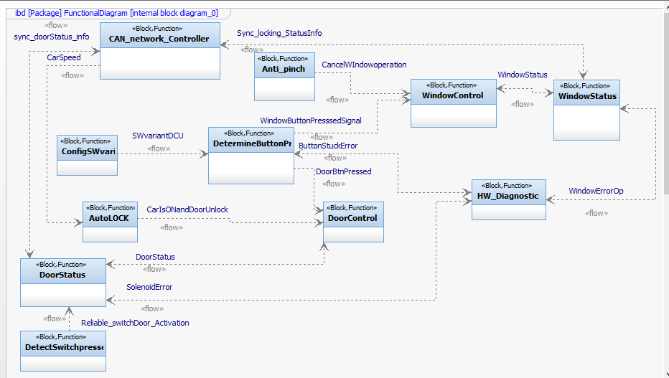

Table of functions
Function Name | Description
DoorControl | Controls solenoid actuation depending on certain conditions
DoorStatus | Reports door status conditions to door control module and solenoid error to Hw_diagnostics.
ConfigSw_ variants | Select Sw variant depending on jumper configuration to perform corresponding behavior according to the following options: driver, passenger,
AutoLOCK | Under certain circumstances if vehicle reaches a speed greater than km this function sends a command to door control to ensure all door lock activation.
Anti_pinch | Detects an object when it is performing a close door operation to prevent a potential hazard cancelling door close operation.
Determine button press | Manages both door button presses and window presses to its corresponding module.
Window control | Depending on certain signals and conditions activate or not the solenoid
Window status | Reports windows status to windows control in order to avoid hardware damage
HW diagnostics | Performs bidirectional communications among determine button pressed, windows status and door status to handle hardware errors.

Table of functional Interfaces
Signal/Event | Description
ButtonStuckError | Sends signal when button is stuck to hardware diagnostics
DoorBtnPressed | Indicates to door control function that a door button was pressed.
WindowButtonPresssedSignal | Indicates to window control function that a window button was pressed.
CancelWIndowoperation | Sends command to window control to cancel close window actuation
SWvariantDCU | Specifies what software version we are using and how we need to configure ECU.
CarIsONandDoorUnlock | Sends signal to close all door when CAN message from brake system shows that is greater than specific speed limit
DoorStatus | Reports to door control window status(completely close, in the middle or completely open)
SolenoidError | Signal used for diagnostic purposes just in case we have a solenoid error.
WindowStatus | Indicates the current status of the windows before make a window operation request.
WindowErrorOp | Indicates if there is an error in the current window operation
CAN_network_Controller | Sends and Receives flows of CAN information incoming and outgoing from ECU and coordinates with windows status and door status whether or not perform any remote pending control operation, when and whom.
DetectSwitchpressed | When windows reaches his end of race both completely close and completely open this performs glitch operation to detect a real switch pressed to change windows status

Functional Interface
Display on a static way the interfaces among SW functions. Block Definition diagram and/or Activity diagram are recommended to describe those interfaces. Include a description for every Diagram included on this section.

Functional interfaces
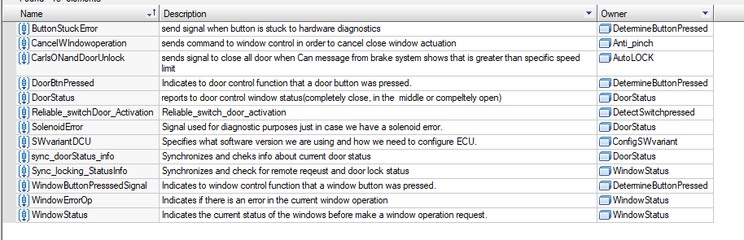

List of functionalities
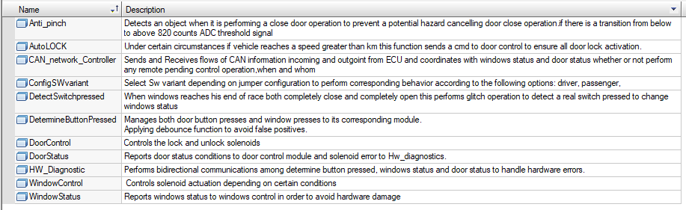

Functional Interaction
Display on a dynamic way the interaction among SW functions. Sequence Diagram and/or Timing diagrams are recommended to describe those interactions. Include a description for every Diagram included on this section.

Window up sequence diagram
Description: When an user press a window up button, determine button pressed function performes a debounce function to determine whether the action was performed by a human and not by noisy environment. Then ask for he sw variant to configSWvarint function to configure the behavior of the ECU.
After that Determine button_press performs type button press function to window control in order to configure the behavior depending on the type of button press detected. Later the function asks for the windows status if the windows status is idle and there is no remote request via CAN then performs the window up action by 500(ms), update window status, report status to CAN network.
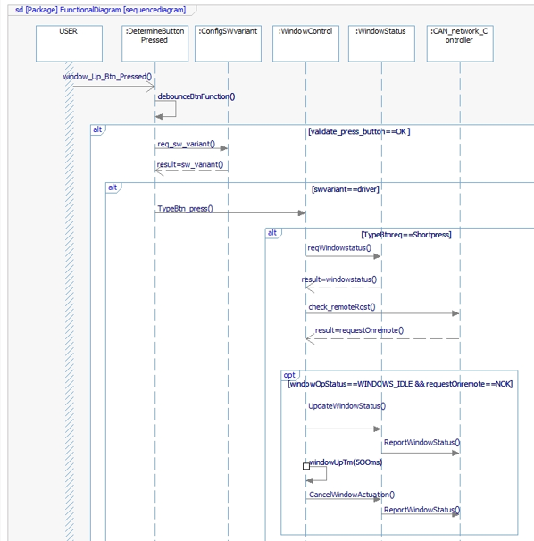

close window sw variant driver sequence diagram
Description: When an user press a close button, determine button pressed function performes a debounce function to determine whether the action was performed by a human and not by noisy environment. Then ask for the sw variant to configSWvarint function to configure the behavior of the ECU.
After that Determine button press function performs a request for close door function to door control and door control asks to door status functionality for current door status and later asks to CAN Network controller if there is a remote request if door status equal to IDLE and there is no remote request via CAN.

SW Physical Architecture
Define Physical architecture that will be implemented on Software with its corresponding SW decomposition.
Identify different SW Components with its corresponding interaction among them.
Identify and describe the signals and events used to share information among SW Components.
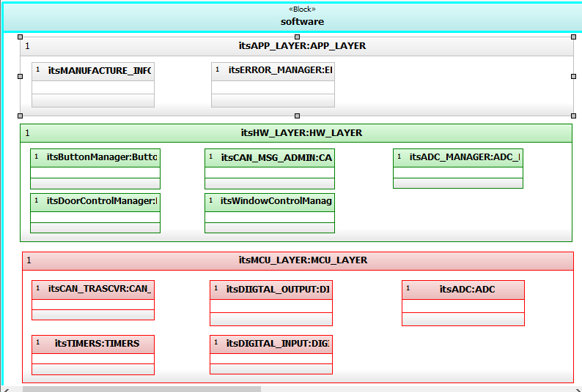

Physical Decomposition
Include a Block Definition Diagram and describe the SW Decomposition. Indicate its estimated size in KB.

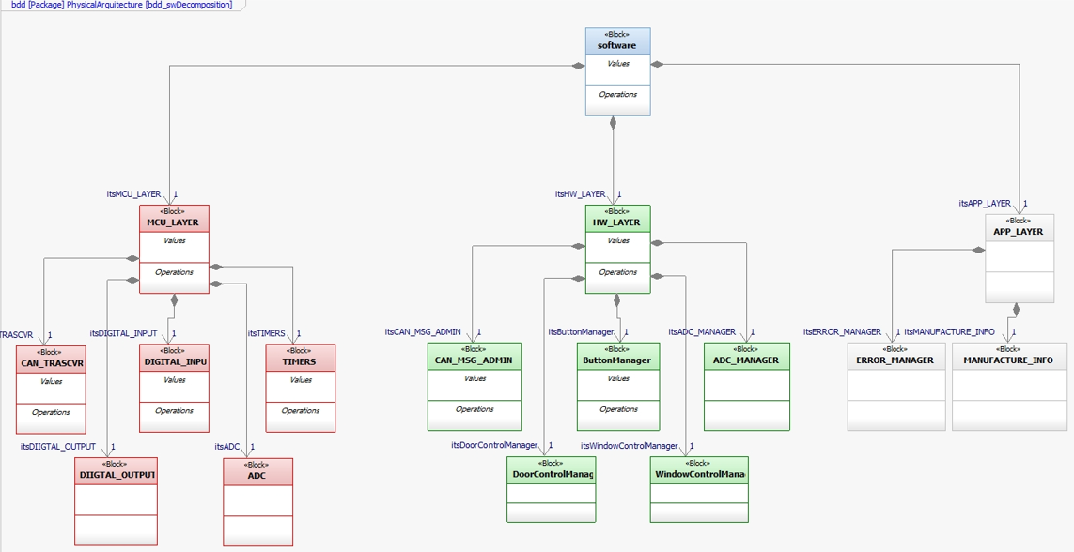

Table of SW components
SWC Name | Description | Estimated Size (KB)
CAN | Software component to define pointers and structures to handle CAN protocol and exposes interfaces to upper layer | 115
DIGITAL INPUT | Software component to define pointers and implements structures to handle digital input peripheral and exposes interfaces to upper layer | 100
DIGITAL OUTPUT | Software component to define pointers and implements structures to handle digital output peripheral and exposes interfaces to upper layer | 100
ADC | Software component to define pointers and implements structures to handle analogic to digital converter peripheral and exposes interfaces to upper layer | 100
TIMER | Software component to define pointers and implements structures to handle hardware timers peripheral and exposes interfaces to upper layer | 85
CAN MSG ADMIN | Sends and receive CAN messages between Door control module and CAN network | 60
BUTTON MANAGER | Implements debounce function for button activation asks for variant version, make request to window control | 20
ADC MANAGER | Implements conversion between ADC counts to digital values to perform depending on conditions an anti pinch cancel window operation. | 20
DOOR CONTROL MANAGER | Implements the logic needed to control door operation and checks door status values | 25
WINDOW CONTROL MANAGER | Implements the logic needed to control window operation and checks window position status values | 25
ERROR MANAGER | Manages error signals from solenoid, window and door | 25
MANUFACTURING INFO | Initializes basic software variant configuration depending on jumper values | 25

Table of Physical Interfaces
Operation | Description
iAntipinch | Sends power mode and speed of the car data to door control manager
iError | Sends signals about window error, button error and door error to the corresponding software components to notify a hardware error but also monitores from them status signals
I_syncDoorCtrlInfo | Monitores external CAN signal to synchronize and update the status variables used by control door operation and allows the remote operation provided by CAN network request
I_synWinCtrlInfo | Monitores external CAN signal to synchronize and update the status variables used by window control operation and allows the remote operation provided by CAN network request
ibuttoncallback | door control uses this callback function to notify and new button event
Ibuttoncallback2 | window control uses this callback function to notify and new button event
ISW_version | Sends sw_variant information required for Button manager

Physical Interfaces
Display on a static way the interfaces among SW components. Block Definition diagram and/or Activity diagram are recommended to describe those interfaces. Include a description for every Diagram included on this section.

Block definition diagram(interfaces)
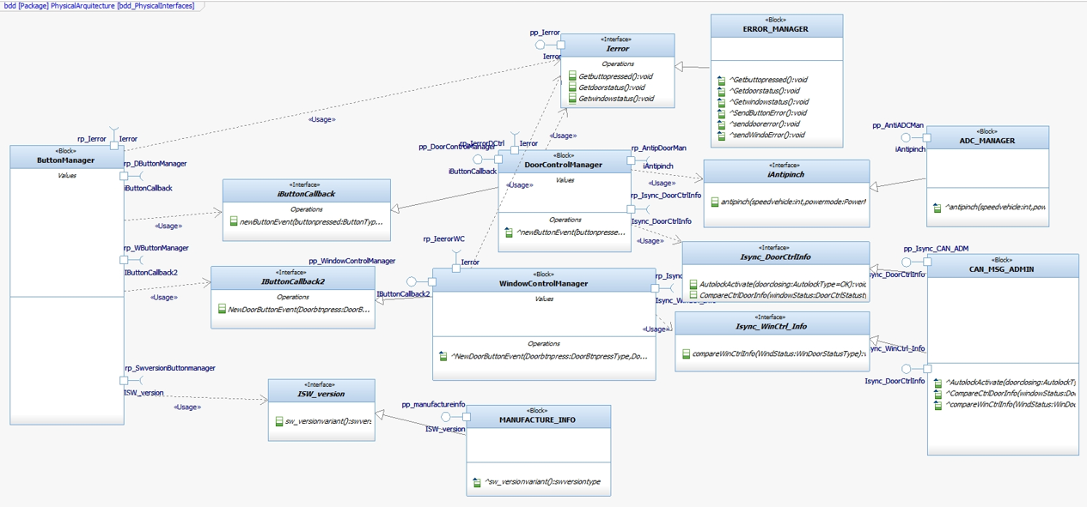

Physical Interaction
Display on a dynamic way the interaction among SW components. Sequence Diagram and/or Timing diagrams are recommended to describe those interactions. Include a description for every Diagram included on this section.

Description:
This sequence diagram performs the use case when user presses window down
When user presses window down button and sends an asynchronous message to button manager and this performs debounce function, after that button manager validates the sw version to configure de system later checks whether it´s a short press or not later checks if there is remote activation request and finally if the windows status is equal to Idle executes window down function and compares window status.
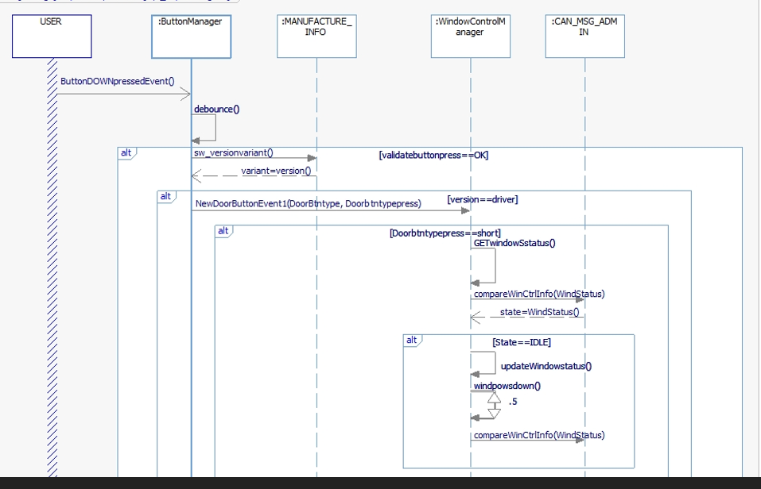

Describe Dynamic Behavior
This chapter shall be used to describe at physical level the runtime behavior of the SW.

OS tasks
OS task | Description | Periodicity | Period | Priority | CPU Load (%)
Task1 | Admin can manager task | 100ms | periodic | 2 | 18
Task2 | Window control manager task | 100ms | periodic | 3 | 10
Task3 | Door control manager task | 100ms | periodic | 3 | 8
Task4 | Anti pinch manager task | 100ms | aperiodic | 1 | 5
Task5 | Button manager task | 100ms | aperiodic | 2 | 4
Task6 | Error manager task | 100ms | aperiodic | 2 | 4
Task7 | Manufacturing info task | 100ms | aperiodic | 4 | 1

Interrupt Handling
ISR task | Description | Priority | CPU Load
1 | CAN INTERRUPT HANDLER | 2 | 4
2 | ADC INTERRUPT HANDLER | 1 | 2

Power Modes

Low Power Mode
There is no power mode

High Power Mode
All tasks described above in section 5.6.1 there will be executed in high power mode

Synchronization Mechanisms
Describe Mechanism used to synchronize process like critical sections, semaphore, mutex, priority ceiling, etc.

MUTEX: mutual exclusion when receiving asynchronous data from ADC and avoid data loss.
MESSAGE QUEUE: There will be probably tasks that needed to share data between task to implement and perform some action

Function to Physical Allocation
Perform the allocation of function to a SW component. One function shall be allocated to one SW component (if this cannot be achieved indicate a clarification wich part of the function shall be allocated to every SW component). One SW component might have

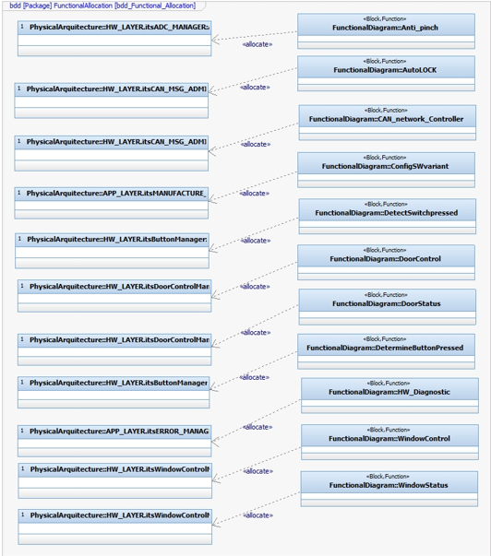

Function | SW component | Clarification
Anti pinch | ADC Manager | Implements conversion between ADC counts to digital values to perform depending on conditions an anti pinch cancel window operation.
Auto lock | CAN MSG Admin | Sends and receive CAN messages between Door control module and CAN network
CAN network controller | CAN MSG Admin | Sends and receive CAN messages between Door control module and CAN network
ConfigSW variant | Manufacture Info | Initializes basic software variant configuration depending on jumper values
Detect switch pressed | Button Manager | Implements debounce function for button activation asks for variant version, make request to window control
Door control | Door Control Manager | Implements the logic needed to control window operation and checks window position status values
Door status | Door Control Manager | Implements the logic needed to control window operation and checks window position status values
Determine button pressed | Button manager | Implements debounce function for button activation asks for variant version, make request to window control
HW diagnostics | Error manager
Window control | Window control manager | Implements the logic needed to control window operation and checks window position status values
Window status | Window control manager | Implements the logic needed to control window operation and checks window position status values

SW Requirements Allocation
Indicates the requirements that will be implemented for every SW component. Use the requirements IDs from Traceability Matrix.

SW Integration Plan
Identify the dependencies for SW construction. Identify hierarchy for implementation. Indicate the integration steps for SW construction.

Integration Step | Description | SW components | Comments
Step 1 | Implements MCU layer | DIO, CAN,ADC,TIMER
Step 2 | Implements HW layer | Button manager, window control manager, door control manager, CAN Message Admin
Step 3 | Implements APP layer | Error manager  Manufacturing info
Step 4 | Implements and synchronize tasks | Task 1, task 2,task 3,task 4, task 5,task 6 and task 7

Functional Safety
This chapter will be fill during Module 5

